Server: Web vs. Application->

Server is a device or a computer program that accepts and responds to the request made by other program, known as client. It is used to manage the network resources and for running the program or software that provides services.

There are two types of servers:

1. Web Server
2. Application Server

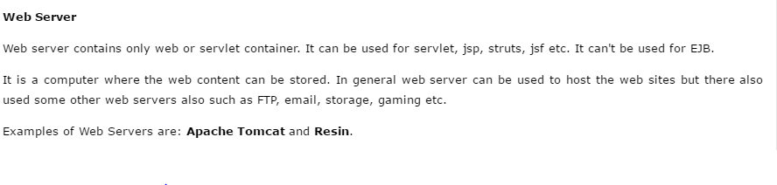

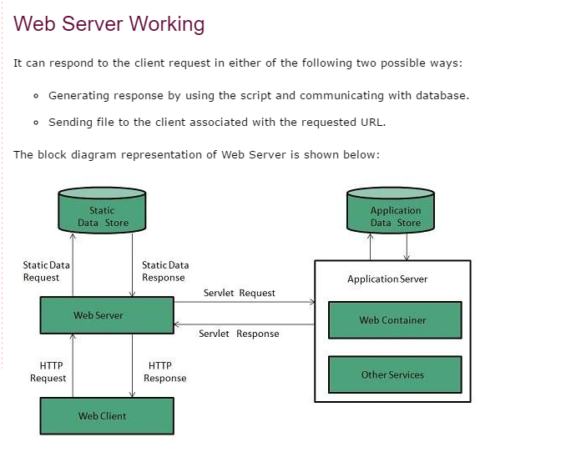

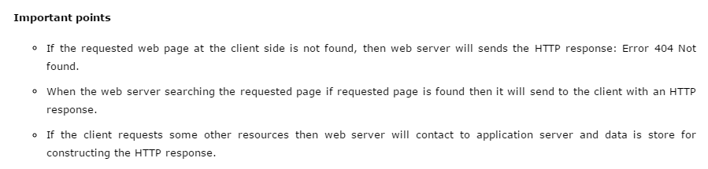

**Application Server->**

Application server contains Web and EJB containers. It can be used for servlet, jsp, struts, jsf, ejb etc. It is a component based product that lies in the middle-tier of a server centric architecture.

